

Melbourne Bike Polo

[melbourne@bikepolo.com.au](mailto:melbourne@bikepolo.com.au)

Albert Park Masterplan

Parks Victoria

Level 10/535 Bourke Street

Melbourne Victoria 3000

[albertparkmasterplan@parks.vic.gov.au](mailto:albertparkmasterplan@parks.vic.gov.au?Subject=Albert%20Park%20Master%20Plan)

Friday, October 31, 2014

Please accept this submission to the Albert Park Master Plan, although we play several nights each week in Albert Park, we only became aware of the development of a new Master Plan stage in October.

**The purpose of this submission is to request the retention and further development of multi purpose hard courts in Albert Park.**

Informal active recreational spaces in urban areas are becoming increasingly important as inner city populations increase and society shifts to a shift away from organised sports. We would like to see the concepts around semi and informal recreational opportunities applied to the provision of sporting facilities in Albert Park.

We currently play several nights a week at the Futsal courts on Aughtie Drive and we find these courts highly valuable to our group as there are an extremely limited number of places in Melbourne where we can access an enclosed flat rectangular space and even less with lights.

We would be strongly supportive of the final Master Plan including a permanent multi-purpose court (slightly larger than the current courts in Albert Park and similar to the one recently constructed in Vancouver)

We understand that a Master Plan is a long term document, and trends in street sports may come and go. By planning for adaptability and flexibility Albert Park will be creating a broader range of opportunities for informal yet active recreation. We look forward to the development of the Master Plan. Please let us know if there are any further opportunities to be involved in the development and implementation of the Master Plan.

Yours sincerely

Damon Rao

Melbourne Bike Polo

## Melbourne Bike Polo submission

Melbourne Bike Polo is currently an informal group who has been playing bike polo for the past 5 years in various locations ranging from car parks to disused tennis courts around Melbourne and adjoining areas. Most of our players are residents of the inner city. We do not have official membership or a playing season and our many regular players are free to come and go on an adhoc basis without having to pay club fees or make a commitment to play every week all season.

Lack of spaces to play and an increasing trend towards risk management has seen us moved on from many of the public and semi public spaces we use. We are now reluctantly looking to incorporate in order to take out an insurance policy so that we may continue to play this new sport that we love.

Through this journey we have discovered that there are dozens of other actively minded people in the same situation as us who lead busy lives or play unconventional sports. Such people are not inclined to make a seasonal commitment to the local football or tennis club.

## Sports Development Framework



Source: City of Yarra Sports Strategy 2008-2012

## Sports Development Framework

This sports development framework, used in planning for community participation in physical activity makes an important differentiation between more organised sports opportunities, and avenues for participation and physical activity.

There is no doubt that in Australia there are plenty of opportunities for people to engage in sport at a high level in a committed environment of development and excellence.

## Less formal participation in sport and the role of public open space

There is currently a lack of variety and opportunities for community participation in sport at a less committed level. Many public facilities are focused around more traditional sports such as football, cricket, netball, tennis and basketball. Participation in many of these sports requires a seasonal financial commitment; clubs who actively work to try and create more opportunities in these areas are faced with an increased emphasis on risk management which has been felt across society in recent years.

## Albert Park Futsal Courts

Albert Park currently provides extensive amounts of grassed open space and provides excellent opportunities for field sports to be played formally and informally. However across Melbourne the range facilities provided for court sports are more formalised, generally provided on a fee for use basis and mostly limited to the specific sport that they were originally designed for. This is usually the case across most other inner city municipalities. **The provision of free and open Futsal hardcourts in Albert Park is unique in inner Metropolitan Melbourne and Parks Victoria should be commended for providing these facilities.**

This submission seeks to ensure that the current courts are credited for the contribution that they make to bike polo and other less traditional or formalised sports, and that these opportunities are developed further in the Albert Park Master Plan

## The future of Australian Sport

CSIRO Futures and The Australian Sports Commission released the Future of Australian Sport Megatrends report in 2013. It reinforces many of the themes and issues that Bike Polo has experienced as an emerging sport left of the mainstream.

Australians love sport. It always has been and will continue to be part of our cultural identity. In particular the report notes the rise of lifestyle, adventure and alternative sports which are particularly popular with younger generations. These sports typically involve complex, advanced skills and have some element of inherent danger and/or thrill seeking.

Adventure, lifestyle, extreme and alternative sports are on the rise. They are also characterised by a strong lifestyle element and participants often obtain cultural self-identity and self-expression through these sports. These sports are likely to attract participants through generational change and greater awareness via online content (e.g. YouTube, Facebook, Twitter).

Participation rates in aerobics, running and walking, along with gym memberships, have all risen sharply over the past decade, while participation rates for many organised sports have held constant or declined (Standing Committee on Recreation and Sport, 2010).

***Rise of non-organised sport and physical activity.***

*The elements of skill, physical exertion and competition are present in both organised and non organised sport. However, organised sports such as cricket, soccer or sailing regattas occur at fixed times and follow structured rules and procedures. Organised sports are typically managed by a sporting club with volunteers or paid staff. They involve a greater level of commitment from participants. In contrast, non-organised sports such as running or playing soccer on the beach are unscheduled and flexible. While participation rates in organised physical activities have remained level over the past decade, participation rates for non-organised physical activities have grown (Figure 2) (Committee of Australian Sport and Recreation Officials, 2011). Non-organised physical activity has a much higher participation rate. Possible explanations are the decreasing willingness of time constrained people to commit to structured sporting activities and a greater emphasis on recreation, health and fitness as opposed to competition.*

More information on this report can be found at: *http://www.csiro.au/Portals/Partner/Futures/Future-of-Australian-Sport.aspx*

## Need for More Flexible Opportunities

There need to be more flexible opportunities for people to be involved in a wider range of less formal sports and physical activities at the lower part of the sports development pathway if we are to ensure that people living in higher density inner urban areas are to lead healthy and active lifestyles.

***Time fragmentation***

*Peoples’ calendars are being more densely packed with immovable events and appointments. This means discretionary time available for sport and leisure is fragmented. Evidence of time fragmentation comes from Australian Bureau of Statistics surveys of time usage (ABS, 2011e). Time is classified as ‘necessary’ (e.g. sleeping, eating), ‘contracted’ (paid work),’committed’ (e.g. collecting children from school) or ‘free’ (e.g. socialising, sport). While necessary and free time of an average person’s day have decreased from 1997 to 2006, the time spent on contracted and committed activities has risen from 39 per cent to 42 per cent (ABS, 2011e). The more people are locked into committed and contracted activities the more time fragmented they become. Consequently they seek, often serendipitous, opportunities to play or watch sport that fit into a busy schedule. (CSIRO, 2013)*

## Informal Court Sports

There is a large range of less formal ‘sports’ such as inline skating, roller derby, flatland bmx, skateboarding, futsal soccer, inline slalom, inline hockey and bike polo that would all benefit from less prescriptive facilities that function more like playgrounds and public spaces rather than formalised sporting facilities. These facilities can be easily designed as multi purpose spaces.

A focus on the creation of informal spaces for social sports will also help to keep courts as open and accessible spaces like play grounds rather than restricted by booking systems and the need for insurance like sports club facilities.

# A multi-purpose sports court

Features of what a basic multi-purpose court space might look like would include:

## A simple yet robust surface

A surface like concrete or bitumen would be ideal.

Cyclists and skaters are often restricted from areas due to damage to highly refined and engineered urban design features that are present in many public spaces in Melbourne.

## A central space clear of poles, grills, grates, furniture, obstructions and other hazards.

Generally the sporting sector is recognising that even support poles on purpose built basketball courts represent a risk to participants and overhead facilities are now installed. This means that a range of participants can now use the space whilst the risks to basketball players is also reduced as is the need for pole padding in outdoor public spaces.

## A space enclosed by an edge, ledge, wall or fence.

This can provide informal seating, edges to grind on or just containment for balls, pucks and even small children. In Vancouver the height of the concrete edge of the multipurpose court in Grandview park was designed to take account of the height of bicycle pedals. The inclusion of a wall can open up even more opportunities for activities like downball.

## A space that provides shelter and light

With sunset generally occurring by close of business each day for 6 months of the year, the provision of light and shelter dramatically increases the opportunities for use of the space throughout the year. Membership fees and court rental are often required to keep more formalised sporting facilities under lights and with a shift to a less formal and organised user base, an approach more akin to street lighting would be required to keep the space viable, usable and safe.

## A space generally rectangular in shape

A space generally at least (20m x 40m) or as large as two basketball courts or two tennis courts allows for a range of uses without consuming too much land. A rectangular space speaks for itself and around the world people understand how to use such spaces whether they be for soccer, tennis or a sport we have never even heard of.

## A public space that is free to use

As emphasised earlier, with a trend towards risk management in sport, barriers to participation are increasing. The success of a multi-purpose space like this would rely on the space being free and open to the public rather than a facility that is highly maintained, managed and provided on a fee for use basis to those who are organised and can afford it.

# Case Study, Grandview Park Redevelopment 2011, Vancouver, Canada

In 2011, the City of Vancouver redeveloped an inner city park. Part of the redevelopment included the replacement of 3 run down tennis courts and the construction of a multi-purpose court built to take account of bike polo and street hockey requirements.

We recently visited this park and took lots of photographs which you can view here:

<http://www.flickr.com/photos/urbanbicyclist/sets/72157627750719478/>

We are also able to provide you with contact details for the City of Vancouver Landscape architects who managed this project.

There is more information about this development at the City of Vancouver website:

<http://vancouver.ca/parks/info/planning/grandviewpark/index.htm>

And

<http://www.straight.com/article-370053/vancouver/east-van-bikepolo-court-world-first>

Whilst there are dozens of tennis courts in inner city Vancouver, this is the first court designed with bike polo in mind but designed with minimal features to maintain a multi purpose philosophy.

# References

Hajkowicz, S.A., Cook, H., Wilhelmseder, L., Boughen, N., 2013. The Future of Australian Sport: Megatrends shaping the sports sector over coming decades. A Consultancy Report for the Australian Sports Commission. CSIRO, Australia.

# Appendix A

## Additional Information

## Current demand in Melbourne, Melbourne Museum example

There is currently a very high level of demand for such a space in Melbourne, although the users aren’t organised enough to demand it. Melbourne museum is the de facto space for a range of hardcourt activities. Simply spending a few hours in this space any evening will expose you a selection of users such as roller derby girls training, inline slalom. Flat land BMX, freestyle fixed gear and several separate groups of inline hockey players and sometimes unicycle hockey players. Currently these activities are tolerated at the whim of Melbourne Museum and Melbourne Exhibition Buildings security and management. This use is also not ideal for the inline hockey players who bring along a large rope to contain the ball.

## Barriers and Opportunities

In the past 5 years as Bike Polo activity has gained popularity, we have encountered a number of barriers which would be worth reviewing for the purposes of forward strategic planning. We would be happy to provide more details about these in the development of the strategy.

## Victoria Gardens shopping centre car park

From 2008 for several years we used to play after hours on the top floor of Victoria Gardens shopping centre car park. The shape of the kerbs, the smooth surface and ambient lighting was suitable for our use and we enjoyed a positive relationship with the security guards. We received a positive response from the management of IKEA who have a 33% stake in the shopping centre and car park. After a formal audit of the car park and comprehensive risk assessment of the entire shopping facility centre management asked us to leave.

* Barriers: Risk, Liability & Insurance requirements
* Opportunities: With local government facilitation, car parking and other commercial spaces could be used outside business hours or peak times for other uses.

## Princes Hill secondary school

From summer 2009 to the end of 2011 we played on the open air basketball court in Paterson St North Carlton. We enjoyed a positive relationship with many residents, the teachers and principal of the school, but complaints from two residents who believed that we had less of a right to use the space than residents of the street made us feel unwelcome and placed the principal in a compromising position. Whilst we were never asked to leave it was not an ideal situation.

* Barriers: proximity to residential areas
* Barrier: there is lack of clarity around shared space use in local areas
* Opportunity: With local government facilitation, school facilities could be shared with the broader community outside school hours.

## Curtain Square basketball court example

The basketball court at the corner of Canning and Newry street in Carlton North would be ideal for multi-purpose use if it were not for the fence being situated beyond the paved surface. This site could be easily adapted to broaden its range of uses.

* Barriers: design of facility for multi-purpose use
* Opportunity: with minimal changes, Curtin square basketball court could become a multi-purpose court.

## Melbourne Museum case study

Melbourne museum is a fantastic opportunity of an unintential space that allows for informal play. The only issue is that there is minimal containment. The multiple rows of bluestone blocks could be realigned into a rectangle to create a multi-purpose event and play space. We understand that this area is not controlled by the City of Yarra or Melbourne but it provides a good case study.

* Barriers: design of facility for multi-purpose use
* Opportunity: with minimal changes, Melbourne Museum could provide a valuable after hours play space away from residential areas.

## Flagstaff gardens

We currently play every Sunday afternoon at Flagstaff gardens on a fee for use basis with The City of Melbourne. The collection of money from players for us to use this space has been a challenge as it has the effect of polarising the group into those who can afford to pay and many who have trouble doing so. We have lost many younger players because of this.

There are also smaller issues with this facility, such as seating just beyond the painted lines. Fortunately the poles are removable. This is the best court we have found so far, unfortunately competition for this space with netball players and tennis players means that we can only book it for one afternoon a week.

* Barriers: financial requirement is an impact on participation
* Barrier: design of facility for multi-purpose use
* Barrier: playing surface type and colour can limit range of uses
* Barrier: high demand with competing users.
* Opportunity: City of Melbourne has already removed the fixed seating improving safety for netball players and usability of the space for wheeled sports.
* Opportunity: future facilities could be designed with a robust playing surface.
* Opportunity: more facilities like this in more places would spread out the demand.
* Opportunity: if new facilities are not developed in a commercial context young and low income users will not be disadvantaged

## Shared and community use of school facilities

There is strong support for shared and community use of school facilities and guidelines for these exist in most states around Australia.

In 2008-09, the Department of Education and Early Childhood Development (‘Department’) undertook research and stakeholder consultation to identify barriers to meeting Government’s commitments to promote and use schools as community hubs.

The review of risk and insurance arrangements resulted in the Department removing the requirement for all not-for-profit community groups, conducting low risk activities, to hold $10 million public liability insurance cover to use school facilities. The changes also mean that school councils no longer need to purchase public liability cover for third parties.

Local councils have a major role in community development and can become key partners with schools. Councils play a range of roles in developing the community, including advocating for the needs of their municipality; undertaking strategic planning; service coordination and provision; securing resources and providing funding; encouraging civic participation; and facilitating community development.

* Opportunity: There is established precedent and a regulatory and policy framework in place for schools to allow community use of facilities.

## Summary table of barriers and opportunities

|  |  |  |
| --- | --- | --- |
| Barrier | Response |  |
| Risk, Liability & Insurance requirements | * Design facilities in public open space * Assist clubs and groups with advice on risk and liability issues. | * Facilities & infrastructure * Services & programs |
| Proximity to residential areas | * Locate facilities away from residential areas | * Facilities & infrastructure |
| Lack of clarity around shared space use | * This indicates unmet demand and competition for facilities as well as conflict with residential areas * Design and provide more multi-purpose facilities * Provide more facilities in more places to meet and spread demand across the municipality * Promote and facilitate community use of school facilities through established frameworks | * Facilities & infrastructure * Services & programs |
| Design of facility for multi-purpose use | * Design new facilities for multi-purpose use * Adapt existing facilities for multi-purpose use | * Facilities & infrastructure |
| Financial impact on participation | * Design facilities in public open space * Services and programs to support opportunities for low income participation * Develop new facilities and opportunities outside a commercial context to encourage participation by young and low income users | * Facilities & infrastructure * Services & programs |
| Playing surface type and colour can limit range of uses | * Design facilities for multi-purpose use | * Facilities & infrastructure |
| High demand with competing users. | * This indicates unmet demand and competition for facilities * Provide more facilities in more places to meet and spread demand across the municipality. | * Facilities & infrastructure * Services & programs |

# Case studies and examples

## Active opportunities underneath freeways

The Burnley climbing wall is another example of an informal active recreation space in Melbourne. The climbing wall existed informally for many years, the product of an active climbing community finding a suitable location. When risk management concerns were raised by CityLink, the facility was shut down and redeveloped as a legitimate space by Parks Victoria. Though not the subject of this submission this is also the kind of facility that we would see as a suitable companion to a multi-purpose court in certain areas, particularly under freeways in inner city locations.

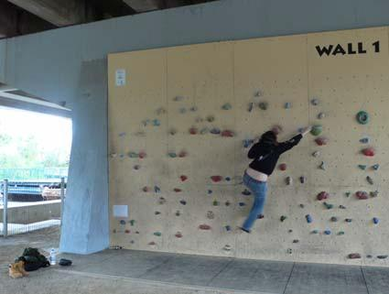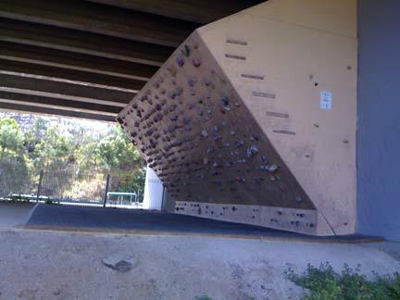

Photo Sources:

<http://www.flickr.com/photos/tommychheng/4296248077>[http://www.flickr.com/photos/7478044@N08/814820710](http://www.flickr.com/photos/7478044%40N08/814820710)

## Case Study, Coopers Skate Park, Vancouver

Coopers’ Skatepark is a multipurpose park accommodating basketball, hockey and skateboarding. Features for skating include benches, coped ledges, a concrete ledge surrounding the basketball court, and various areas around the court leaving the central clear for a range of complementary uses. You can literally skate all day, any day, as the bridge provides a bit of cover from the rain and lights provide a bit of illumination during the evenings (usually turning on at about 9pm).

We have many more photos of the different aspects of this park which you can view here:

<http://www.flickr.com/photos/urbanbicyclist/sets/72157627806351104/>

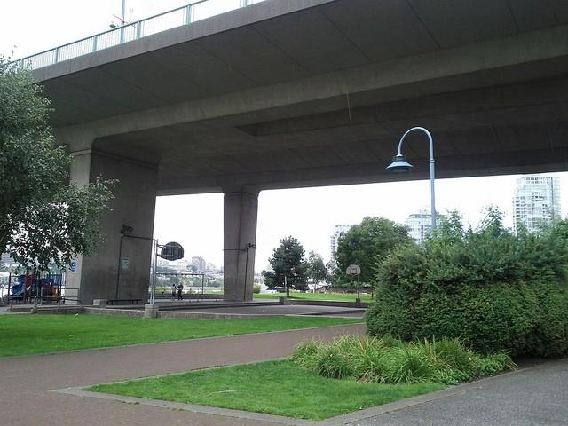

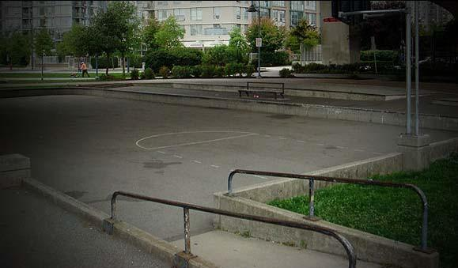

## Current Informal Uses at Melbourne Museum

An example of the kinds of activities that multi purpose space might support at a Moonee Ponds Creek linear park or other inner city urben renewal area. Who knows what other mixed up or reinvented sports we might be playing by 2030?

## Roller Derby

<http://www.flickr.com/photos/bernd_ploderer/4151679198>

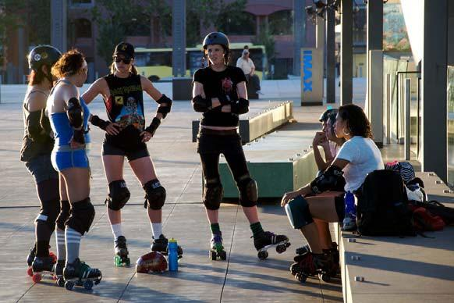

## Inline skaters

<http://www.flickr.com/photos/lucidpieces/3263036184>

## 

## Unicycle Hockey

<http://www.flickr.com/photos/nopunintended/2731241985>

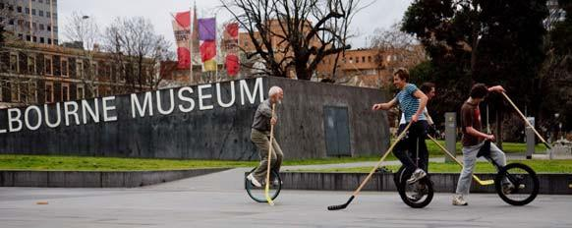

## Inline Hockey

<http://www.flickr.com/photos/drabbate/5614506694>

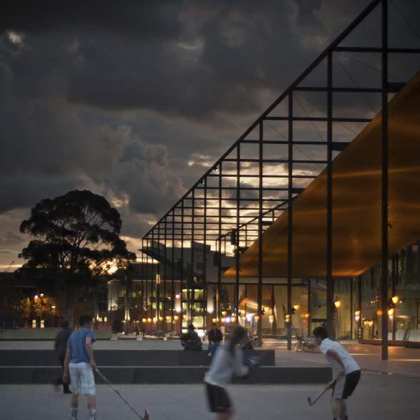

## Inline Hockey

[http://www.flickr.com/photos/32614668@N00/2836123418](http://www.flickr.com/photos/32614668%40N00/2836123418)

## 

## Freestyle BMX

[http://fiveprime.org/hivemind/Tags/blackandwhite,bmx/Timeline](http://fiveprime.org/hivemind/Tags/blackandwhite%2Cbmx/Timeline)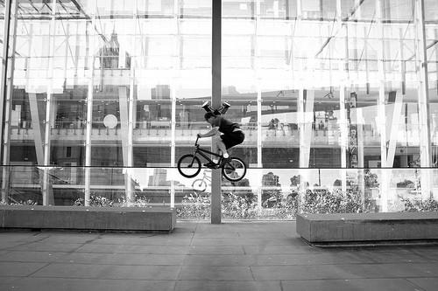

## Fixed Freestyle

<http://prollyisnotprobably.com/2011/06/a_day_in_10_photos_06052011_me.php>

